Setup Arduino IDE

Download and install latest Arduino IDE version from the link.

<https://www.arduino.cc/en/software>

Open **code.ino** file in Arduino IDE.

Go to **Tools** >> **Board** >> **Boards Manager**.

Search for **Giga boards** and download latest version.

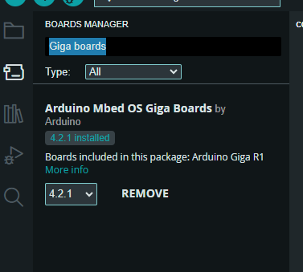

Connect board with PC, Select **port** and **board**.

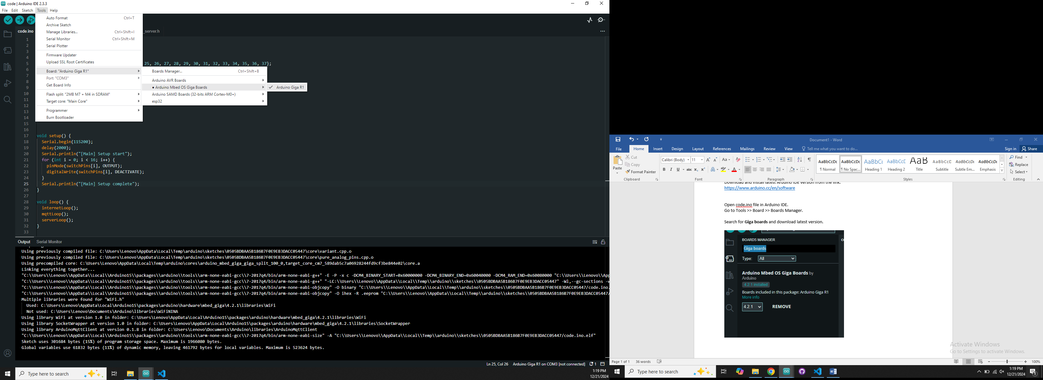

Enter Wi-Fi credentials.

In **internet.h** file update Wi-Fi name and password.

